
CST2213
BUSINESS INTELLIGENCE PROGRAMMING -2 ADVANCED CONCEPTS
Project Phase 2: Data Preparation & Initial Analysis

- Data Cleaning and Preprocessing

In the Survey of Consumer Finances dataset, it was observed that the column YY1 (Respondent ID) was duplicated five times due to applied imputation techniques on continuous variables, e.g. Income, Net Worth, Asset, Debt, etc.
There were no missing values observed from this dataset. Outliers and conversion of features were handled within the process of feature engineering.

- Data Integration and Transformation

This project utilizes only one dataset (Survey of Consumer Finances). Data was loaded into the notebook using pandas. It was then aggregated to a single respondent level (YY1) to reduce multiple imputations per respondent. Statistical methods were performed to the attributes below:
Attribute | Description | Statistical Method
AGECL | Age group of the reference person | Mode
EDCL | Education category of reference person | Mode
MARRIED | Marital status of reference person | Mode
KIDS | Total number of children in household | Mode
KNOWL | Respondent's knowledge of personal finances | Mode
OCCAT1 | Occupation categories for reference person | Mode
FAMSTRUCT | Family structure of household | Mode
HHSEX | Gender of household reference person | Mode
NOFINRISK | Respondent not willing to take financial risk | Mode
YESFINRISK | Respondent willing to take financial risk | Mode
ASSET | Total value of assets held by household, 2019 dollars | Mean
INCOME | Total amount of income of household, 2019 dollars | Mean
NETWORTH | Total net worth of household, 2019 dollars | Mean
EQUITY | Total value of financial assets held by household that are invested in stock, 2019 dollars | Mean
DEBT | Total value of debt held by household, 2019 dollars | Mean

- Exploratory Data Analysis (EDA)

The following information were obtained after analyzing the data:
  - Dataset dimension
    - There are 22,975 data points and 357 attributes.
  - Descriptive statistics
    - Numerical variables
 | ASSET | INCOME | NETWORTH | EQUITY | DEBT
count | 22975.000000 | 22975.000000 | 22975.000000 | 22975.000000 | 22975.000000
mean | 20317046.257824 | 1592855.207682 | 19956403.324635 | 5864321.191456 | 360642.933188
std | 110925570.288364 | 12442710.392028 | 110170716.217272 | 55440799.285854 | 2544356.013837
min | 0.000000 | 0.000000 | -555500.000000 | 0.000000 | 0.000000
25% | 63850.000000 | 42155.561122 | 35907.500000 | 0.000000 | 0.000000
50% | 539800.000000 | 94039.328657 | 384500.000000 | 17000.000000 | 29000.000000
75% | 2716900.000000 | 264823.396790 | 2476105.000000 | 475000.000000 | 217000.000000
max | 2387780900.000000 | 458230949.400000 | 2387780900.000000 | 1890230000.000000 | 131990000.000000

    - Categorical variables
 | ASSET | INCOME | NETWORTH | EQUITY | DEBT
count | 22975.000000 | 22975.000000 | 22975.000000 | 22975.000000 | 22975.000000
mean | 20317046.257824 | 1592855.207682 | 19956403.324635 | 5864321.191456 | 360642.933188
std | 110925570.288364 | 12442710.392028 | 110170716.217272 | 55440799.285854 | 2544356.013837
min | 0.000000 | 0.000000 | -555500.000000 | 0.000000 | 0.000000
25% | 63850.000000 | 42155.561122 | 35907.500000 | 0.000000 | 0.000000
50% | 539800.000000 | 94039.328657 | 384500.000000 | 17000.000000 | 29000.000000
75% | 2716900.000000 | 264823.396790 | 2476105.000000 | 475000.000000 | 217000.000000
max | 2387780900.000000 | 458230949.400000 | 2387780900.000000 | 1890230000.000000 | 131990000.000000

  - Visualizing distribution
    - Net Worth, Income, and Debt is right skewed. Most respondents were at the lower end of the distribution.
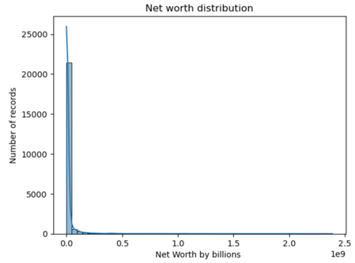
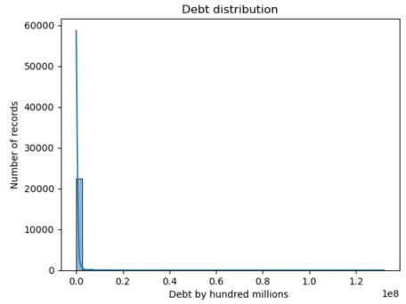
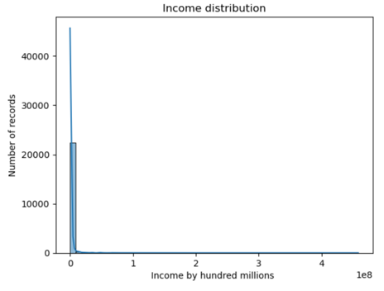

  - Correlation Matrix
    - Positive
      - INCOME, NETWORTH, ASSET, EQUITY (strong)
      - DEBT to INCOME, NETWORTH and EQUITY (moderate)
      - OCCAT1 (Occupational Category) to AGECL(Age Class) and EDCL(Education Class) (moderate)
    - Negative Correlation
      - EDCL (Education Classification) to NOFINRISK (No Financial Risk) (moderate)
      - KNOWL (Financial Knowledge) to NOFINRISK (No Financial Risk) (moderate)

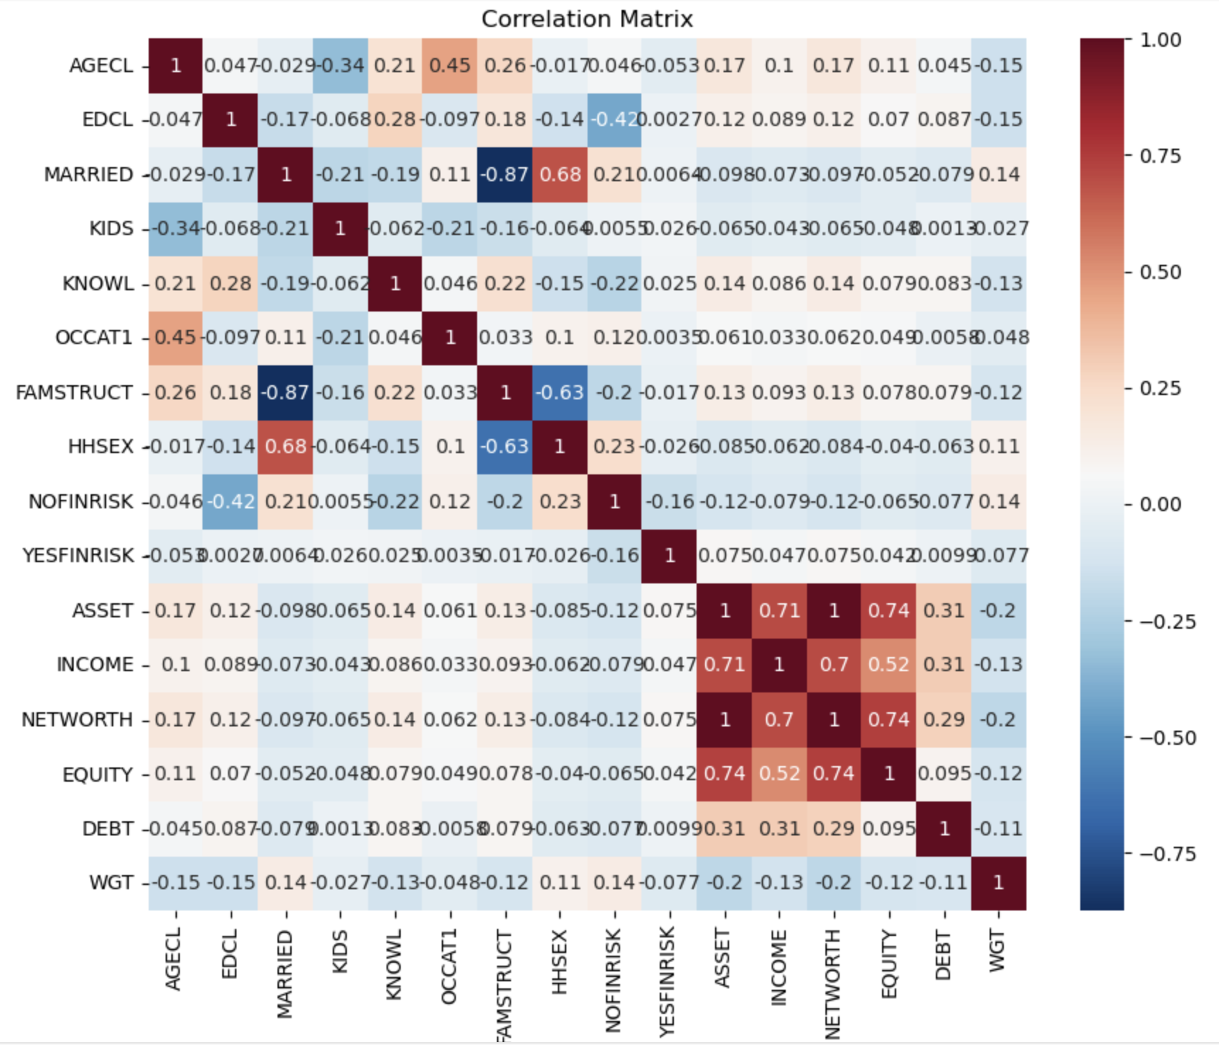

- Feature Selection and Engineering
  - Selected Key Attributes
    - YY1
    - AGECL
    - EDCL
    - MARRIED
    - KIDS
    - KNOWL
    - OCCAT1
    - FAMSTRUCT
    - HHSEX
    - NOFINRISK
    - YESFINRISK
    - ASSET
    - INCOME
    - NETWORTH
    - EQUITY
    - DEBT
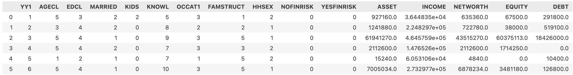

  - Derived Attributes
    - Knowledge Group (categorical)
    - Metrics
      - Equity to Asset Ratio (numerical)
      - Debt to Asset Ratio (numerical)
      - Debt to Income Ratio (numerical)
      - Equity to Asset Score (numerical)
      - Debt to Asset Ratio Score (numerical)
      - Debt to Income Ratio Score (numerical)
      - Risk Profile (categorical)

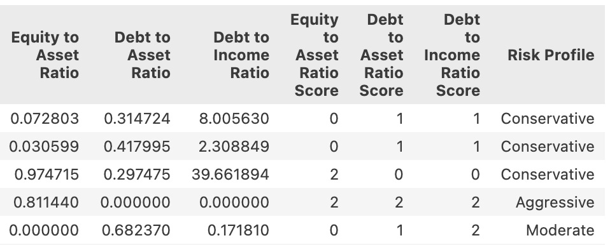

Next step would be choosing the model and integrating the dataset to the application.

